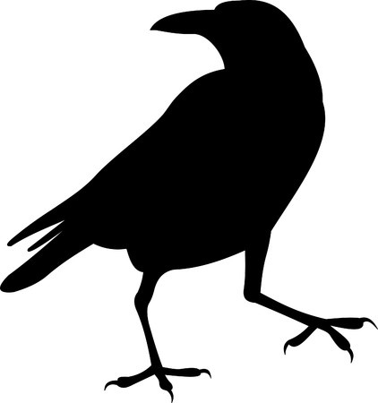
Edgar Allan Poe Webquest

Name:
You will search for the following information and provide the domain name to cite your source. Please do not provide lengthy web addresses—just the domain name will do! Be sure to use at least three different sources to gather your information. You may email the webquest to me (Dianne.Rodriguez@cobbk12.org) or you may print it. Assignment is worth 35 pts (5pts each question.) Due today, end of period!!!!
ELAGSE7W8: Gather relevant information from multiple print and digital sources, using search terms effectively
ELAGSE7RL4: Analyze the impact of rhymes and other repetitions of sounds

- In what year was Edgar Allan Poe born? What year did he die?
________________________________________________________________________________________________________________________________________________________________Domain name:

- How were Edgar Allan Poe’s stories published? Books? Magazines? eBook?
________________________________________________________________________________________________________________________________________________________________Domain name:

- What is Poe’s style or genre of writing?
________________________________________________________________________________________________________________________________________________________________Domain name:

- True or False: Edgar Allan Poe is an American Writer
Domain name:

- Copy and paste a picture of Poe here:
Domain name:

- Please list three unusual facts about Poe:
__________________________________________________________________________________________________________________________________________________________________________________________________________________________________________________________________________________________________________________________________________________________________________________________________________________________________________________________________________________________________________________________________________
Domain name:

- Copy and paste the first stanza of Poe’s poem The Raven below. Mark the end rhyme scheme using letters. Also mark the type of rhyme: slant, eye or identical

