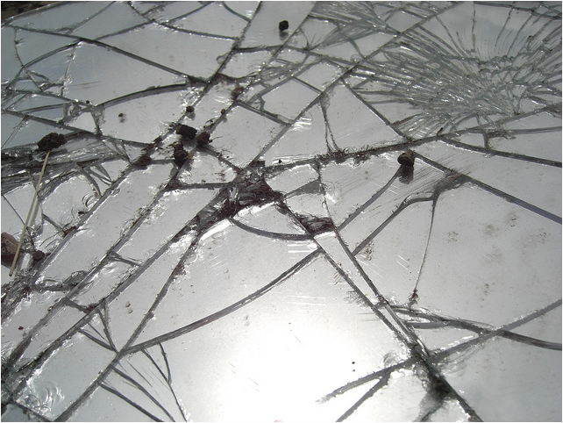

Four questions on The Intelligence Quotient is a Fractured Mirror
Name________________________________________

Directions: Please answer the following questions using complete sentences. Also use at least one piece of text evidence in each answer. A complete answer will consist of 4 to 5 well written sentences

1. What is the argument being made in this text?

2. What is the proof of the author’s claim?

3. What is the metaphor in this text?

4. How does the metaphor build the author’s argument?

