How to access Clever at home:
- Use Google Chrome and search for Cobb Clever
or use the link http://bit.ly/cobbclever
- At the Cobb County School District selection screen, select Log in with Clever
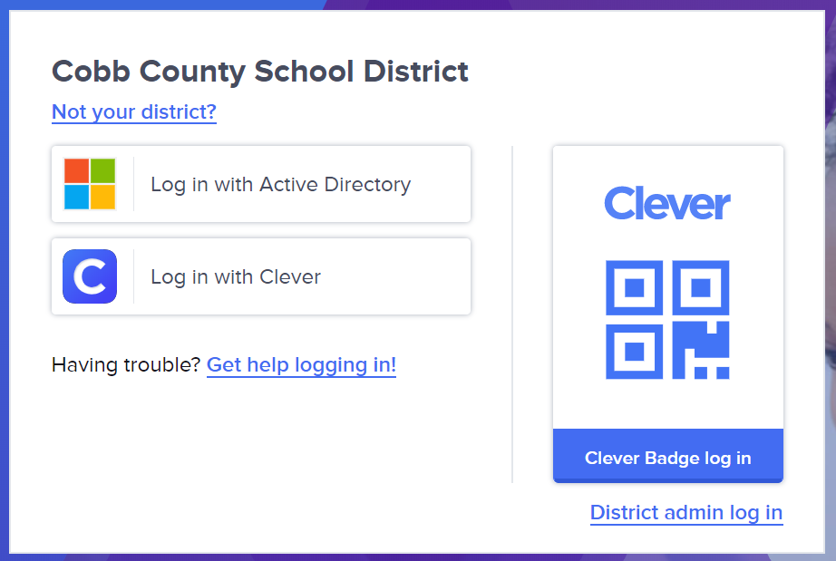
- At the login screen, sign in using:
Username: Student ID (lunch #)
Password: Student ID (lunch #)
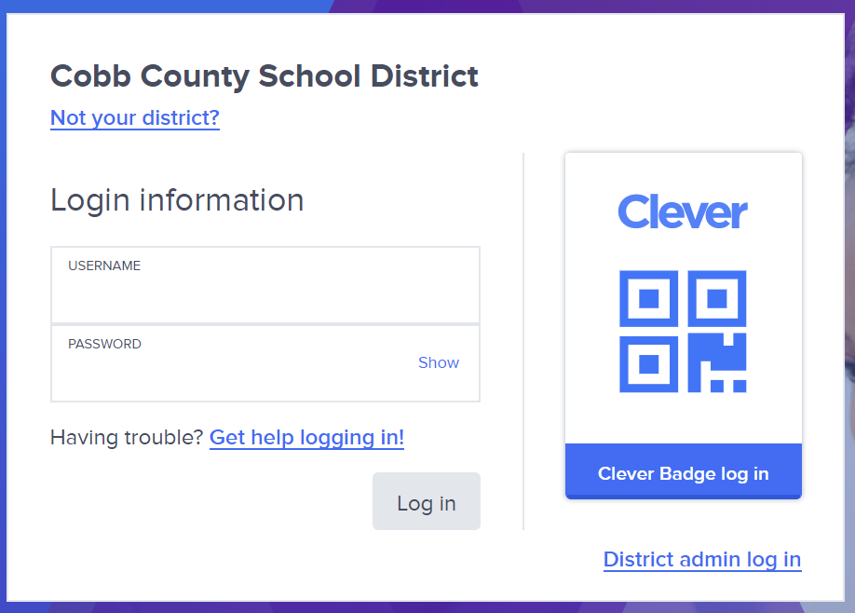
- If this is your first time logging in, you will be prompted to change your password. YOUR NEW PASSWORD SHOULD ALSO BE YOUR STUDENT ID (LUNCH #). Do NOT change to a new password.
- Under District Apps, select
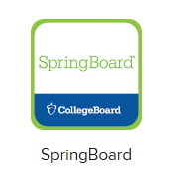
- Explore Unit 4 and find assigned task

